

|  |  |
| --- | --- |
| **Modelo** | MEC-D3/101A |

|  |  |  |  |  |  |  |  |  |  |  |
| --- | --- | --- | --- | --- | --- | --- | --- | --- | --- | --- |
| MULTIPLICADOR  Revoluciones/ Relación | MODELO | l/min | 2000 | 2220 | 2600 | 2800 | 3000 | 3500 | 4000 | 4500 |
| m3/hora | 120 | 132 | 156 | 168 | 180 | 210 | 240 | 270 |
| l/seg | 33.3 | 36.7 | 43.3 | 46.7 | 50 | 58.3 | 66.7 | 75 |
| 955/1:3,35  835/1:3,83 | MEC-D3/101A | **H** | **109** | **109** | **108** | **107** | **106** | **103** | **100** | **95** |
| P | 79.5 | 83.5 | 90.5 | 94.5 | 97.5 | 106 | 114 | 121 |

H = Altura de impulsión manométrica total en m.

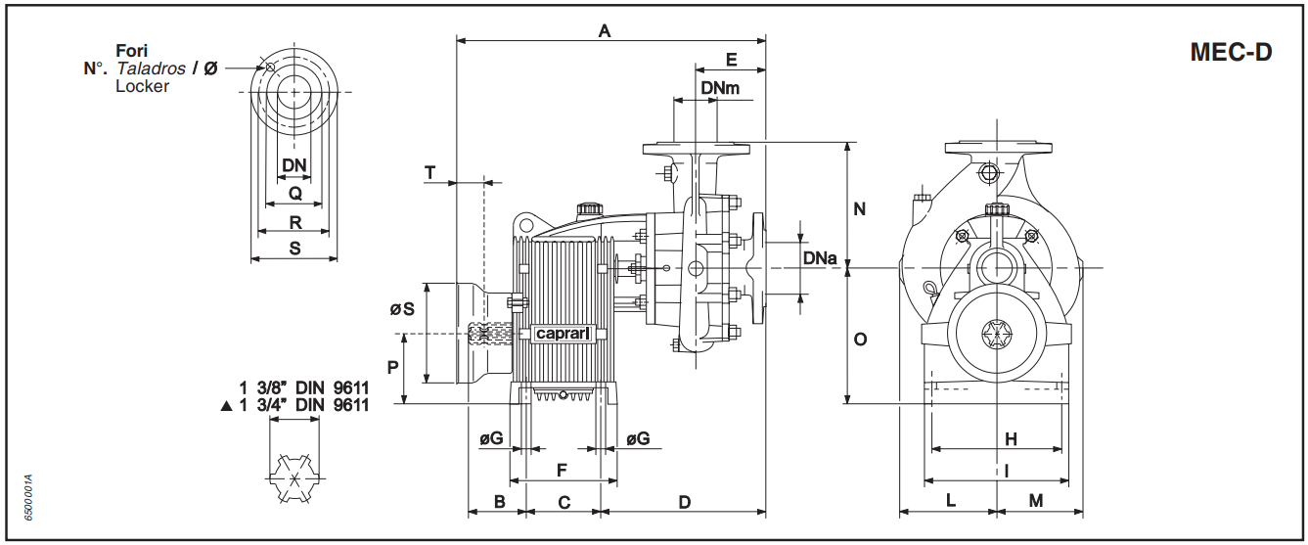P = Potencia absorbida en HP.

|  |  |  |  |  |  |  |  |  |  |  |  |  |  |  |  |  |  |  |  |
| --- | --- | --- | --- | --- | --- | --- | --- | --- | --- | --- | --- | --- | --- | --- | --- | --- | --- | --- | --- |
| **MODELO** | DNa | DNm | A | B | C | D | E | F | G | H | I | L | M | N | O | P | S | T | PESO |
| MEC - D 3/101 | 125 | 100 | 693 | 105 | 180 | 325 | 147 | 220 | 18 | 225 | 290 | 220 | 188 | 300 | 281 | 145 | 240 | 118 | 123 |

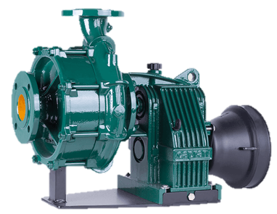

|  |  |
| --- | --- |
| **BRIDAS** | |
| Ø Boca | 125 |
| Q | 188 |
| R | 210 |
| S | 250 |
| N° Taladro | 8 |
| Ø Taladro | 18 |

|  |  |
| --- | --- |
| **BRIDAS** | |
| Ø Boca | 100 |
| Q | 158 |
| R | 180 |
| S | 220 |
| N° Taladro | 8 |
| Ø Taladro | 18 |

|  |  |
| --- | --- |
| **Potencia nominal del tractor** | |
| kW | 103 ÷ 110 |
| HP | 140 ÷ 150 |